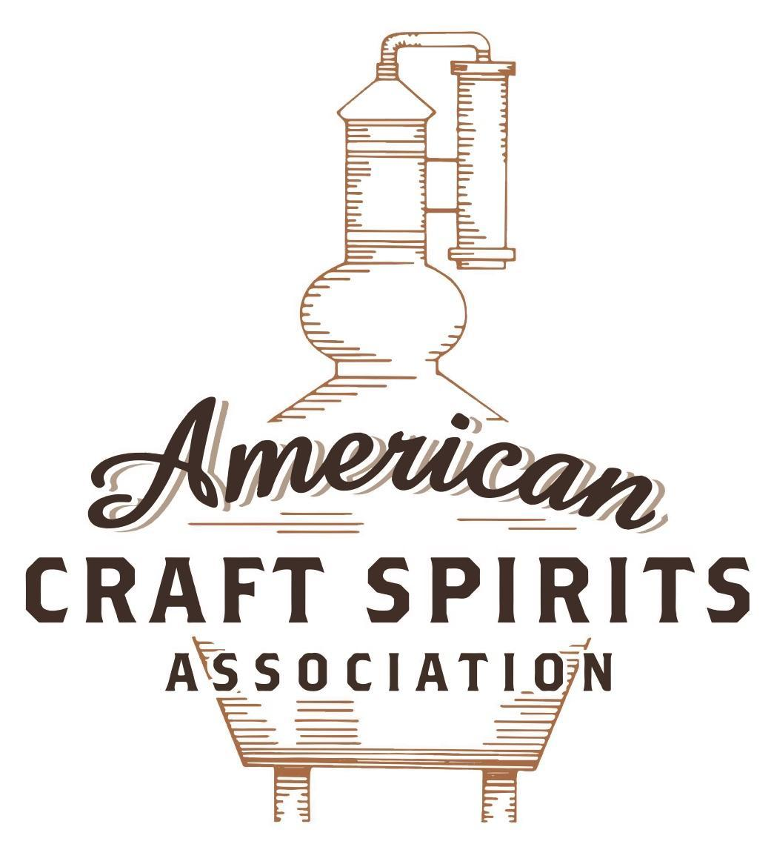
Spirits DtC Shipping Guide

This guide summarizes the direct-to-consumer shipping rules for distilleries in all 50 states and D.C. and also addresses the measures state governments have taken to ease delivery and shipping restrictions during the COVID-19 pandemic.

DtC Quick Guide Comparison

Out-of-State Distilleries  Can Ship Into State? |  |  |  | In-State Distilleries  Can Ship Within State?
State | Yes | No |  | State | Yes | No
AL |  | X |  | AL |  | X
AK | X |  |  | AK | X
AZ | X |  |  | AZ | X
AR |  | X |  | AR |  | X
CA |  | X* |  | CA |  | X*
CO |  | X |  | CO |  | X
CT |  | X* |  | CT |  | X
DE |  | X |  | DE |  | X
DC | X |  |  | DC | X
FL |  | X |  | FL |  | X
GA |  | X |  | GA |  | X
HI |  | X* |  | HI |  | ?*
ID |  | X |  | ID |  | X
IL |  | X* |  | IL |  | X*
IN |  | X |  | IN |  | X
IA |  | X* |  | IA |  | X*
KS |  | X |  | KS |  | X
KY | X |  |  | KY | X
LA |  | X |  | LA |  | X
ME |  | X* |  | ME |  | X*
MD |  | X |  | MD |  | X
MA |  | X |  | MA |  | X
MI |  | X |  | MI |  | X
MN |  | X |  | MN |  | X
MS |  | X |  | MS |  | X
MO |  | X |  | MO |  | X
MT |  | X |  | MT |  | X
NE | X |  |  | NE | X
NV |  | X* |  | NV |  | X
NH | X |  |  | NH |  | X*
NJ |  | X* |  | NJ |  | X*
NM |  | X |  | NM |  | X
NY |  | X* |  | NY |  | X*
NC |  | X |  | NC |  | X
ND | X |  |  | ND | X
OH |  | X |  | OH |  | X
OK |  | X |  | OK |  | X
OR |  | X |  | OR | X
PA |  | X* |  | PA |  | X
RI |  | X* |  | RI |  | X
SC |  | X |  | SC |  | X
SD |  | X |  | SD |  | X
TN |  | X |  | TN |  | X
TX |  | X |  | TX |  | X
UT |  | X |  | UT |  | X
VT |  | X |  | VT |  | X
VA |  | X |  | VA |  | X
WA |  | X* |  | WA | X
WV |  | X* |  | WV |  | X*

WI |  | X |  | WI |  | X
WY |  | X |  | WY |  | X

Notes:
*CA: If passed and signed into law, Senate Bill 620 would allow licensed distilled spirits producers in states other than California and licensed distilled spirits manufacturers or craft distillers in California who obtain distilled spirits direct shipper permits to ship directly to consumers in California
*CT: Consumers with appropriate permit may receive alcohol shipments
*HI: Consumers with appropriate permit may receive alcohol shipments; If passed and signed into law, Senate Bill 65 would allow licensed distilled spirits manufacturers in Hawaii and in states other than Hawaii who obtain direct shipper permits to ship directly to consumers in Hawaii
*IL: If passed and signed into law, Senate Bill 0532 would allow licensed distilled spirits producers in Illinois and in states other than Illinois who obtain distillery shippers’ licenses to ship directly to consumers in Illinois
*IA: If passed and signed into law, House File 639 would allow native distilled spirits manufacturers in Iowa and in states other than Iowa who obtain direct shipper permits to ship directly to consumers in Iowa and to consumers in states other than Iowa
*ME: If passed and signed into law, Legislative Document 1358 would allow distilleries outside of Maine with current manufacturer licenses and distilleries licensed in Maine who obtain spirits direct shipper licenses to ship directly to consumers in Maine
*NJ: (1) If passed and signed into law, Assembly Bill 3167 would allow a craft distillery licensees to ship no more than 9 liters of distilled spirits to a consumer in New Jersey; (2) If passed and signed into law, Senate Bill 3020 would allow craft distillery licensees in New Jersey or in states other than New Jersey to ship no more than 20 liters of distilled spirits to a consumer in New Jersey via common carrier
*NV: Licensed individuals can import one gallon per month of spirits for personal use and the out-of-state supplier must pay excise tax
*NH: If passed and signed into law, Senate Bill 125 would allow licensed liquor manufacturers who obtain direct to consumer shipping permits from the commission to ship directly to consumers in New Hampshire
*NY: Consumer may import up to 90L of liquor per year for personal use without a license; If passed and signed into law, Assembly Bill 3275 would allow licensed liquor manufacturers in states other than New York and licensed distillers and farm distillers in New York to ship no more than thirty-six cases (no more than nine liters per case) of liquor to consumers in New York
*PA: Consumer may place a special liquor order and distiller must ship to a PLCB-operated store
*RI: Distiller can only ship to customer if order was personally placed by customer at distiller's premises
*WA: If passed and signed into law, House Bill 1432 would allow licensed spirits manufacturers in states other than Washington to ship spirits to consumers in Washington
*WV: Distilleries, mini-distilleries, or micro-distilleries licensed in West Virginia or a state other than West Virginia who obtain private direct shipper licenses to ship to a consumer in West Virginia, however the shipments must be made to a retail liquor outlet

NEW MEXICO
Shipment Outbound – No, a craft distiller may export, but can only sell to persons holding a wholesaler’s, a craft distiller’s, or a manufacturer’s license (N.M. Stat. § 60-6A-6.1(B)(2);(3).
Shipment Inbound – No. Manufacturers with a nonresident license may only sell or ship into the state alcohol to NM licensed manufacturers and wholesalers (N.M. Stat. § 60-6A-7(C)).
Shipment Intra-state – No. Craft distilleries are not allowed to ship directly to individuals, they may only sell directly to customers on their premises for off-premise consumption or at no more than three other locations off the craft distiller's premises, after the craft distiller has obtained the appropriate license (N.M. Stat. §60-6A-6.1(B)(7);(8)).
COVID-19 Measures – Craft distilleries were allowed to remain open for take-out service only. H.B. 0255, signed and enacted into law on March 9, 2021, allows a craft distiller’s license holder to obtain an alcoholic beverage delivery permit. A licensee that holds an alcoholic beverage delivery permit may contract with a third-party alcohol delivery service licensed by the department.
Restrictions on Alcohol Sales Pursuant to Department of Health Emergency Order Issued April 6, 2020 Link:
http://rld.state.nm.us/uploads/files/Alcohol%20and%20Gaming/April%207%20Letter%20Covid.PDF
H.B. 0255 Link: https://www.nmlegis.gov/Sessions/21%20Regular/final/HB0255.pdf
Citation (shipment)
New Mexico Statutes
§ 60-6A-6.1. Craft distiller's license.
A. In any local option district, a person qualified pursuant to the provisions of the Liquor Control Act, except as otherwise provided in the Domestic Winery, Small Brewery and Craft Distillery Act, may apply for and be issued a craft distiller’s license subject to the following conditions:
(5) nothing in this section shall prevent a craft distiller from receiving other licenses pursuant to the Liquor Control Act.
B. A person to whom a craft distiller's license is issued pursuant to this section may do any of the following:
(1) manufacture or produce spirituous liquors, including aging, filtering, blending, mixing, flavoring, coloring, bottling and labeling;
(2) store, transport, import or export spirituous liquors;
(3) sell only spirituous liquors that are packaged by or for the craft distiller to a person holding a wholesaler's license, a craft distiller’s license or a manufacturer's license;
(7) conduct spirituous liquor tastings and sell, by the glass or by the bottle, or in unbroken packages for consumption off the premises but not for resale, spirituous liquors of the craft distiller's own production or spirituous liquors produced by another New Mexico craft distiller or New Mexico manufacturer on the craft distiller's premises; and
(8) at no more than three other locations off the craft distiller's premises, after the craft distiller has paid the applicable fee for a craft distiller's off-premises permit, after the director has determined that the off-premises locations meet the requirements of the Liquor Control Act and department rules for new liquor license locations and after the director has issued a craft distiller's off-premises permit for each off-premises location, conduct spirituous liquor tastings and sell by the glass, or in unbroken packages for consumption and not for resale, spirituous liquors produced and bottled by or for the craft distiller or spirituous liquors produced and bottled by or for another New Mexico craft distiller or manufacturer.
§ 60-6A-7. Nonresident license.
C. Nonresident licensees may sell, offer for sale or ship into the state alcoholic beverages only to licensed New Mexico manufacturers and wholesalers.
Link to NM Statutes: https://www.rld.state.nm.us/uploads/FileLinks/78247e84a1c24fb4a463d898a7133117/Liquor_Control_Act_Part_1_101811_.pdf

The American Craft Spirits Association (ACSA) is working diligently to give our members and industry partners relevant, current updates on statutes and regulations impacting production, sale and distribution of spirits. With the declaration of the novel coronavirus (COVID-19) in early 2020, many states have issued temporary policy changes or longer-term modernization of alcohol beverage laws. State statutes, regulations created by the state alcohol regulatory authority, as well as any other relevant guidance provided by such authorities (such as advisories, opinions, bulletins, etc.) were reviewed in creation of this document. No city or county ordinances were reviewed. Distillers should be aware that even in states where direct shipping is permissible, always remember to avoid shipping to dry counties. Please consult with your state guild or alcohol beverage authority for the most up-to-date information. This content is intended for educational and informational purposes only. ACSA's pro bono law firm of Malkin Law P.A. provided the core content found in this comprehensive overview of the spirits distribution after COVID-19. It was completed in August 2021 and will be updated regularly. If you have updates you would like to provide, please send to legislation@americancraftspirits.org or directly to the law firm at: ryan@malkin.law / malkin.law. Thank you.

